Bahria University,

Karachi Campus

LAB EXPERIMENT NO.

6

LIST OF TASKS

|  |  |
| --- | --- |
| TASK NO | OBJECTIVE |
| 1 | Create a web service of online add to cart system |
| 2 | Create a simple calculator web service to perform task |

Submitted On:

19-06-2023

(Date: DD/MM/YY)

**Lab 6**

**Task 1:**

Create a web service of online add to cart system

using System.Web.Services;

namespace Webservice2

{

[WebService(Namespace = "http://tempuri.org/")]

[WebServiceBinding(ConformsTo = WsiProfiles.BasicProfile1_1)]

[System.ComponentModel.ToolboxItem(false)]

public class WebService1 : System.Web.Services.WebService

{

public static List<string> cart = new List<string>();

[WebMethod]

public string Cart(string items ,int quantity)

{

cart.Add(items + " "+ quantity);

return " Added!! ";}

[WebMethod]

public List<string> Price_list()

{

return cart;}}}

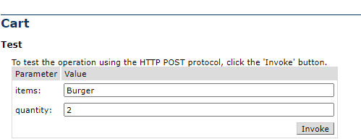**Output:**



**Task 2:**

Create a simple calculator web service to perform task

**Service.cs**

using System.Web.Services;

namespace Webservice

{

[WebService(Namespace = "http://tempuri.org/")]

[WebServiceBinding(ConformsTo = WsiProfiles.BasicProfile1_1)]

[System.ComponentModel.ToolboxItem(false)]

public class mywebservice : System.Web.Services.WebService

{

[WebMethod]

public string HelloWorld()

{

return "Hello Buddy!!";

}

[WebMethod]

public int addition(int a, int b)

{

return (a + b);

}

[WebMethod]

public int subtraction(int a, int b)

{

return (a - b);

}

[WebMethod]

public int multipication(int a, int b)

{

return (a * b);

}

[WebMethod]

public int division(int a, int b)

{

return (a / b);

}

**Output:**

**Subtraction:**

